Assignment 1 Result:

Question 1:

AIM:
To create a program that generates 5 possible PAN Cards for a given name and condition.

Code:

"""
Assignment 1 Question 1 done by Vansh Aggarwal
Date: 6/3/24
Time of start: 13:22

"""

#import

import random

# take inputs

temp = "ABCFGHLJPT"
i=1
name = input("Enter name: ")

print ('''
o A Stands for Association of Persons (AOP)
o B Stands for Body of Individuals (BOI)
o C Stands for Company
o F Stands for Firm
o G Stands for Government
o H Stands for HUF (Hindu Undivided Family)
o L Stands for Local Authority
o J Stands for Artificial Judicial Person
o P Stands for Individual
o T Stands for AOP (Trust)
''')
opt1 = input("Enter Letter of category: ")

# define all the functions

def check_3letters():
x1 = random.randint(65,90)
x2 = random.randint(65,90)
x3 = random.randint(65,90)

l3 = chr(x1) + chr(x2) + chr(x3)

return(l3)

def check_4letter(o1):
global opt1

while True:
if opt1 in temp:
return(opt1)
else:
opt1 = str(input("Enter Letter of category: "))

def check_letter5(name):
l = name.split()
return(l[len(l)-1][0])

def seq_num():
n1= str(random.randint (0,9))
n2= str(random.randint (0,9))
n3= str(random.randint (0,9))
n4= str(random.randint (0,9))

seq = n1+n2+n3+n4
return (seq)

def check_digit (PAN):
sum = 0
for i in PAN:
if ord(i)>= 65 and ord(i) <= 90:
sum += ord(i)-65

else:
sum += int(i)
rem = (sum%26) +64
let = chr(rem)
return (let)

# Main Loop for all functions

for i in range (5):
PAN = str(check_3letters()) + str(check_4letter(opt1)) + str(check_letter5(name)) + str(seq_num())
check = check_digit (PAN)

print ("Possible PAN number" , i+1, PAN + check)

Sample Output:
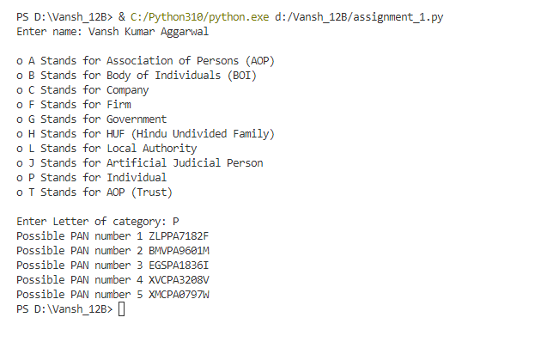

Question 2:

AIM:
To code a split function for a given string.

Code:

"""
Assignment 1 Question 2 done by Vansh Aggarwal
Date: 15/3/24
Time of start: 11:53

"""

opt1 = 0

def string_to_list(main_string, split_string,opt1):
i=0
req_list = []
temp = ""
if opt1 == 1 or opt1 ==2:
check_num = len (split_string)
while i <= (len(main_string)- check_num):
if main_string [i] == split_string[0]:
main_string[i: (i+check_num+1)] == split_string
req_list.append(temp)
temp =""
i+=check_num

elif main_string [i] != split_string[0]:
temp += main_string[i]
i+=1
req_list.append(temp)

elif opt1 == 3:
for i in main_string:
if i != " ":
temp += i
elif i == " " and temp != "" and temp != " ":
req_list.append(temp)
temp = ""

return (req_list)

while opt1 != 4:
main_string = input ("Enter Main String: ")

print('''
1. split string value is a substring
2. split string value is space
3. split string value is not given.
4. exit.
''')
opt1 = int(input("Enter option number: "))

if opt1==1:
split_string = input ("Enter the split string: ")
elif opt1 ==2:
split_string = " "

elif opt1 ==3:
split_string = " "

elif opt1 == 4:
break

else:
print ("input not recognised")
break

print (string_to_list (main_string, split_string,opt1))

Sample Output:
